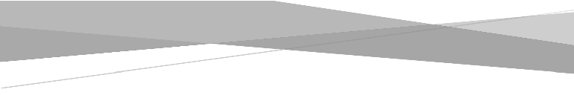

Publish Shape File

TrueCAT Version 6.0
Date: June 2019

Contents

Purpose 2
Work Flow 2

Prerequisites 3
Data Preparation 5
- Download the Shape File 5
- Size of the shape file should not be more than 50 Mb 5
- Shape file should have the projection 4326 (WGS 84) 8
- How To Create Style File? 9

Publish Shape File 10

- Publishing Shape file in TrueCAT 10

Appendix: Set Symbology in QGIS 11

Purpose
TrueCAT application allows users to understand the risk accumulations based on political boundaries (country/state/county/zip) or combinations of these. This document discusses different options that user can use to understand the risk accumulations and exposed limits.

The exposed limit functionality has 3 different parts.
- Creating a new exposed limits option based on manual or file mode
- Running an exposed limit analysis with damage ratio options
- Administrative functionality that allows admin to control which exposed limit analyses options are viewed by underwriters and branch managers

Creating a new Exposed Limits file

This option is available to only senior members of the team with user roles: Portfolio Manager, Admin or Senior Executive

There are two way to create Exposed Limit File:
Manual Mode
Manual mode allows users to quickly create a zone for exposed limits calculations without having to spend time in creating files.
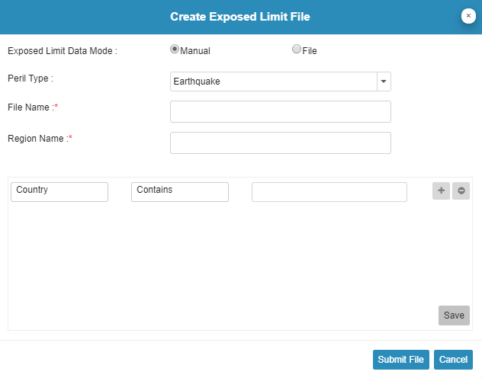

User will be able to create exposed limit file with different regions for all six peril to submit the job.
- Select peril from peril type drop down
- Provide “File Name”: Each file can contain multiple regions
- Each region may contain combination of fields – CountryCode, StateCode, CountyName and PostalCode
- The hierarchy of the field is: CountryCode >> StateCode >> CountyName >> PostalCode.
Filters should be selected in above manner only. If user wants to add CountyName, then country code should be selected first, then state code; similarly, for postal code, all the above hierarchy should be selected first.
- After applying all the filters, Click on Save button so that filtered values will be saved for a particular RegionName. And same can be seen on bottom left of the create exposed limit file panel
- User can also remove any Region, from cross button on added Region
- Repeat the process to add new Region
- Click “Submit” button to save the file
File Mode:

File mode allows users to create multiple zones and quickly upload them into TrueCAT application. User can also create exposed limit file by uploading .csv file with mandatory fields and sequence of fields should also be same as mentioned below.

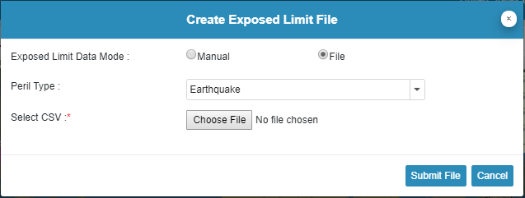

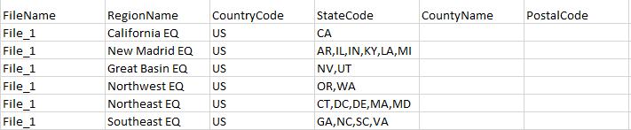

FileName: This is a name given and will be shown in the drop down for exposed limit file selection
Region Name: this is an exposed limit accumulation zone name. This name needs to be exactly same with the one in the damage ratio file. While using exposed limit file on UI, Data of rows having same File Name will be grouped together and will be visualized as a single file.

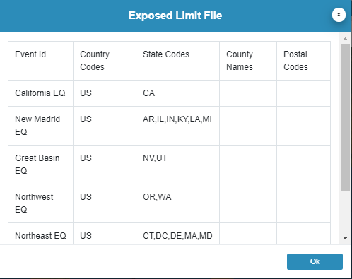
Validations:
The exposure data must contain the exact same data for column name and no validation is done against the exposure data.
- Name of Column Headers has to be in the order below or it will prompt error.
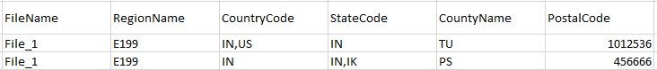
- CountryCode / StateCode / CountyName may contains single or comma separated multiple values. In a particular row, if any column has multiple comma separated values or blank, then successive column values will be ignored, since it is not a valid scenario.


e.g. in the file above, in 1st row, columns after country code are ignored while in 2nd row, columns after statecode are ignored.

If there are multiple “event IDs” that has similar exposed zones, TrueCAT will calculate the losses independently for each zone.

Creating Damage Ratio File:

Option to create and upload damage ratio file is available to only admin and portfolio manager user. All the file name should not be more than 15 character.

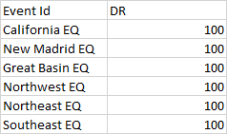

The “Event ID” in the damage ratio file should be exactly same as the one that was used in the “RegionName” column in Exposed limit file. “Event ID” needs to be the first column of the file. The DR column has to be the last column in the damage ratio file list.

All the other columns in the “Event ID” and “DR” should be BldgClass, OccType, CONSTRUCTION_GROUP, OCC_MAJOROCCUPANCYGROUP, YEARBUILTRANGE, NUMSTORIESRANGE, BUILDINGVALUE_DR, CONTENTVALUE_DR, APPTSTRUCTVALUE_DR, BIVALUE_DR or LocationID. The other columns are optional and are reviewed from left to right. Please view the damage ratio file creation documentation for further review.

Exposed Limit Analysis in TrueCAT:

If you have an Admin or Portfolio Manager role, you will see the below dialog where you will have an option to select the Exposed limit file and Damage Ratio (DR) file. Given an analysis name and submit the job to HPC.
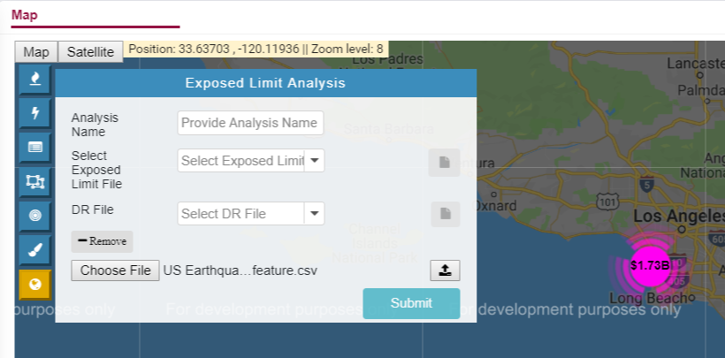

SHOW THE SCREENS HOT WITH THE RESULTS

Exposed Limit Job Authorization:

Underwriters and branch managers don’t have access to import or create exposed limit file or damage ratio files. They can use the files created by admin or portfolio manager user only if similar access has been provided. Similar to other job types like shape, custom shape and ring, the exposed limit job will be “visible to underwriters” only if it has been authorized by the admin or portfolio manager user from the TrueCAT UI.

The Analysis Job authorization option is available under the “User Account” section in TrueCAT. The user will need to select the Peril and click on the + sign to show additional details. It then needs to select analysis name, exposed limit file name and damage ratio file name that it wants to exposed to underwriter and branch managers.

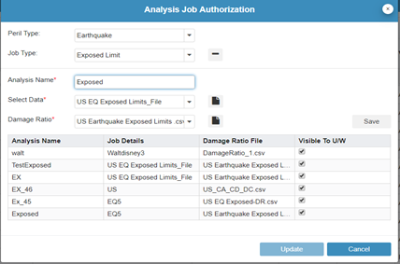

As an underwriter or branch manager, the user will have an option to select the analyses that have been authorized to view and run from the TrueCAT UI. They will see the dropdown selection in the analysis Name section. The Exposed limit file and DR file will be automatically selected based on the analysis name selection. The user will still have ability to view the contents of the file and run analysis as necessary.

